**Billing System**

A SYNOPSIS SUBMITTED ON PARTIAL FULFILLMENT OF THE REQUIREMENTS FOR THE AWARD OF

THE DEGREE OF

**BACHELOR OF TECHNOLOGY in COMPUTER SCIENCE & ENGINEERING**

**SUBMITTED BY**

SAHIL KHAN

BU2016UGCS046

Computer Science Department

2016-2020

**SUPERVISED BY**

Mrs. Parul Gazta, Assistant Professor

COMPUTER SCIENCE & ENGINEERING

**SUBMITTED TO**



COMPUTER SCIENCE & ENGINEERING DEPARTMENT

BAHRA UNIVERSITY, SHIMLA HILLS

Waknaghat - 173234, Distt. Solan (H.P.)

Academic Session:

2016-2020

**Introduction**

Billing System is a desktop based application for daily needs stores and retail shops to manage their product billing and other billing related tasks.

Billing System helps to store the product and customer related data and is able to generate bills.

Billing System is able to store and print the invoices from the database and helps to manage the product and invoice data.

**Software requirements:**

* Windows operating system
* MS Access Database

**Technology used:**

* Dot Net
* C#

**Hardware requirements:**

* Hard Disk – 500MB
* RAM – 512MB
* Processor-Dual core or above

**Motivation**

The motivation behind this project is to store the sold product information and also the customer information who bought the product. It also helps to calculate the sold product price with CGST and SGST prices.

This system will help to generate the invoices and manage the customer data with sold product information.

**Related Work**

The present method of generating the invoices, saving transactions, and calculations with cgst and sgst prices requires separate software for each mentioned above.

This software helps to maintain the data with an easy and ordered manner.

**Proposed Method**

To overcome the issues like maintaining user and products data and also calculation with current cgst and sgst prices and generate invoices , this Billing System is introduced.

Billing System is a faster and easy to use software.

It is extremely reliable software and also data inserted, updated, deleted easily.

There is no need to use paper to store the user and product information.

The Billing System helps to insert ,update, delete products data easily.

Owner can easily track and search the previous data of the user.

Owner can also search the product data by generated invoice numbers.

**Flow Chart**

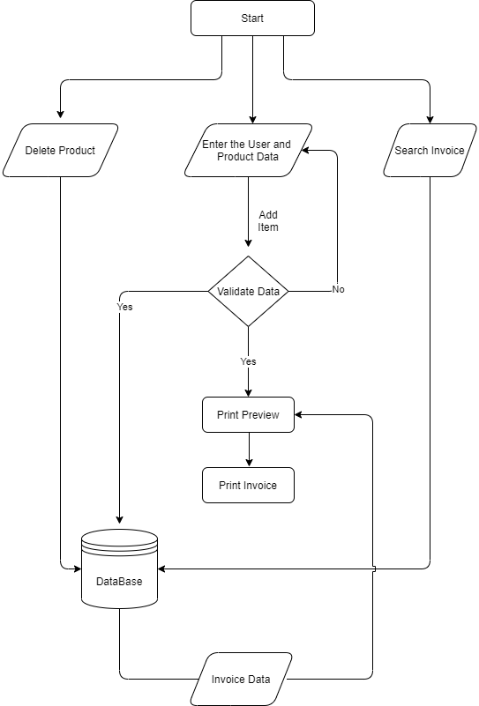

**Methodology**

SDLC – Waterfall Model:

The methodology chosen for this project is SDLC Waterfall Model. It refers to the Software Development Life Cycle Waterfall Model. This model is easy to implement and illustrates the software development process in a linear sequential flow.

⦁ Requirement Gathering and analysis − All possible requirements of the system to be developed are captured in this phase.

⦁ System Design − The requirement specifications from the first phase are studied in this phase and the system design is prepared. This system design helps in specifying hardware and system requirements and helps in defining the overall system architecture.

⦁ Implementation − With inputs from the system design, the system is first developed in small programs called units, which are integrated in the next phase.

⦁ Integration and Testing − All the units developed in the implementation phase are integrated into a system. Post integration the entire system is tested for any faults and failures.

⦁ Deployment of system − The product is deployed on the multiple systems.

⦁ Maintenance − There are some issues which come up in the client environment. To fix those issues, patches are released. Also to enhance the product some better versions are released. Maintenance is done to deliver these changes in the customer environment.

The next phase is started only after the defined set of goals are achieved for the previous phase, hence the name "Waterfall Model". In this model, phases do not overlap.

**Project Details**

Name: Billing System

Technology to be used: C#, Dot NET, MS Access Database

Objective: To create a desktop application that can perform tasks such as generate invoices, manage user and product data, calculating the price with cgst and sgst as a single unit.

Scope of the Project: Every product outlet needs a system like this to manage the invoices and product data. Billing System is very useful in:

⦁ Retail Shops

⦁ Retail Store

⦁ Factory Outlet

⦁ Shops

**Conclusion**

Billing System is an application which is very useful and reliable to handle customer data.

It provides multiple features to maintain customer data easily.

It helps to store and use product data easily.

Therefore, Billing System can be used in shops and outlets to maintain the product data and used to perform multi tasks.